 Sri Meenakshi Govt.Arts College for Women (A),

Madurai - 625 002

 Department of Physics

Naan Mudhalvan Scheme

Domain : Sales Force Associate

Title id :NM2023TMID05141

Project Tile : Implementing CRM for Result tracking of a candidate with internal marks

Submitted by

TEAM VI

Team Lead : Ms.Vinothini.S

Team Member 1 : Ms.Vasuki.G

Team Member 2: Ms. Vijaya lakshimi.T

# 

Mentors : Dr. K. Vijaya Kumar & Dr. P. Indra Devi

Assistants Professors, Department of Physics, Sri Meenakshi Govt.Arts College for Women, Madurai

April, 22 - 2023

**PROJECT REPORT TEMPLATE**

**INTRODUTION**

**1.1Overview**

CRM implementation definition is the process of deploying CRM software for the company to track and manage its communication with current and potential customers

CRM implementation is the process of [introducing a CRM system](https://nethunt.com/blog/what-is-a-crm/) to your business. It starts from choosing the right solution for your needs, and ends with actively using it to streamline your business processes.

**1.2Purpose**

Implementing a CRM system is a value-adding process that can bring great benefits to any business. The ultimate goal is to improve communication and interaction with real customers and leads, and to maximise their impact on the production process and business figures.

**Problem Defination & Design Thiniking**

**2.1 Empathy Map**

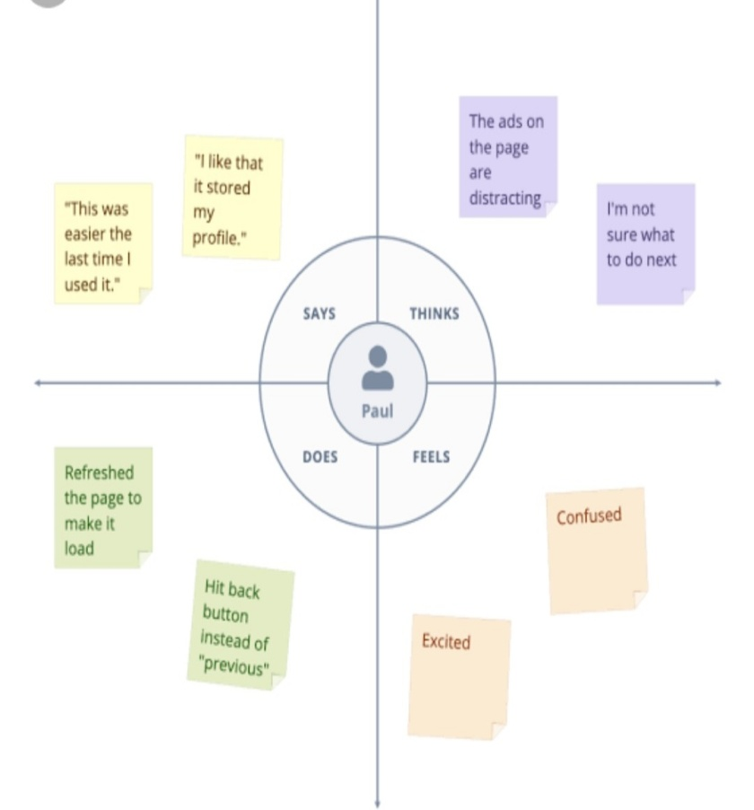

2.2 Ideation & Brainstorming Map

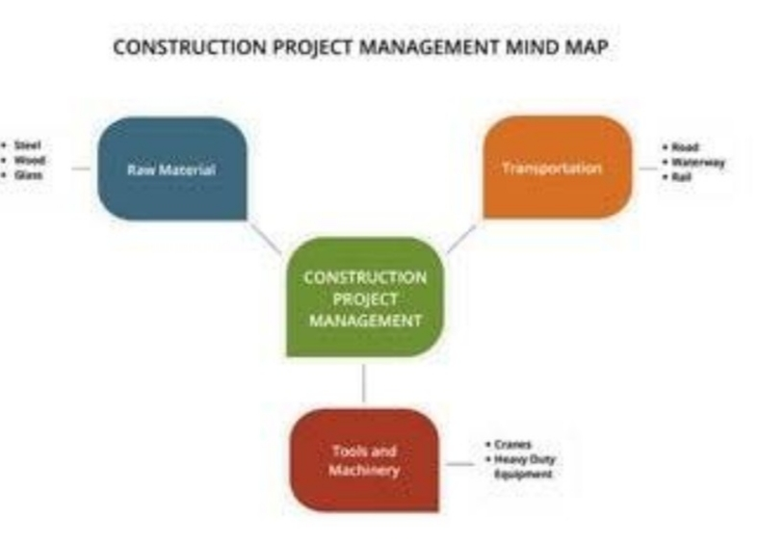

**RESULT**

**3.1 Data Result**

|  |  |
| --- | --- |
| **Object** | **Fields in the Object** |
| Obj 1 | |  |  | | --- | --- | | Field label | Data type | | Text | Semester | |  |  | |

**3.2 Activity & Screenshot**

**Activity 1** 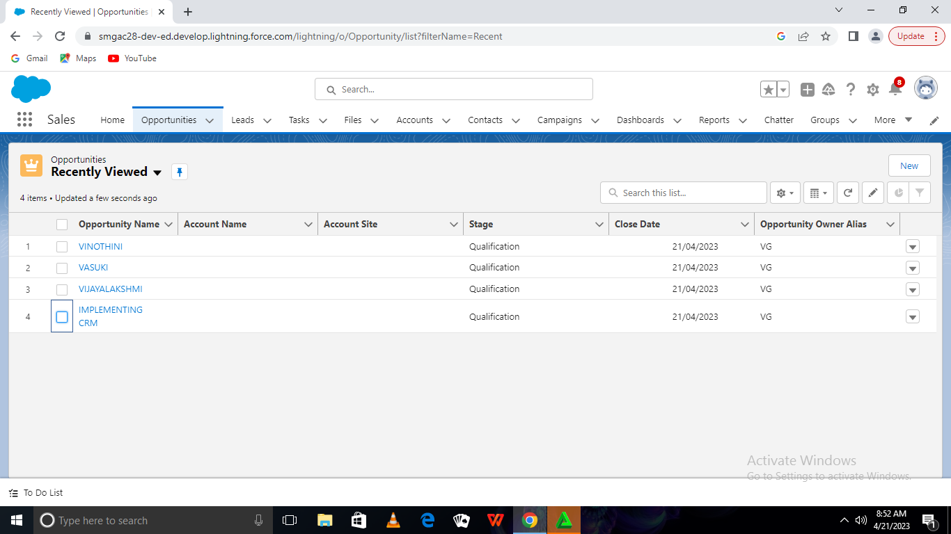

**DESCRIPTION**

The scope of CRM includes a wide range of activities, from manage information to developing personalized marketing campaigns. In order to be effective, CRM must be tailored to the specific needs of each business. As such, the scope of CRM can vary greatly from one company

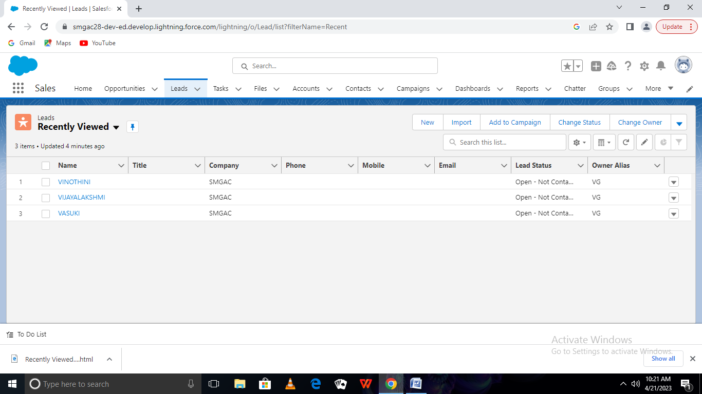

**DESCRIPITION**

In most CRM systems, the term lead is used to describe an individual who might become your customer, but currently isn't. To put it simply, a 'lead' is your potential customer. Naturally, you would like to collect and manage as much actionable information about your leads as possible, which is what CRM systems are for.

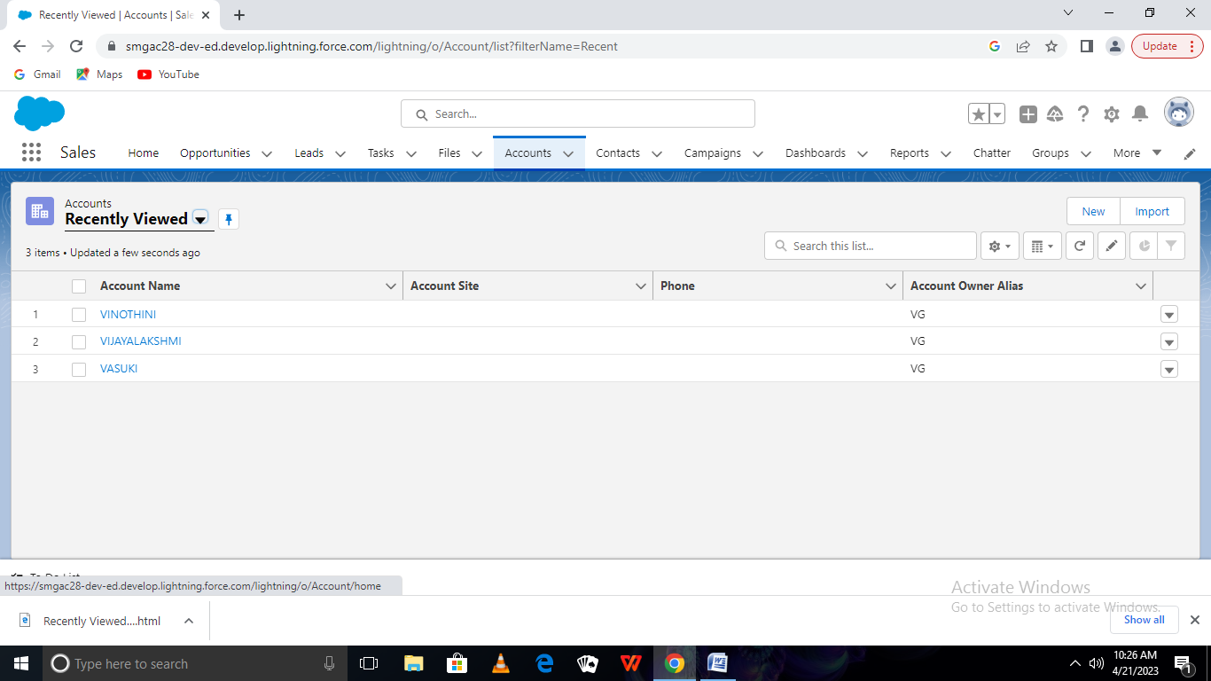

**DESCRIPTION**

A CRM will enable a sales manager to:​​ Access **data for goal setting analytics**, team meetings, and reporting to executives. Update and override account

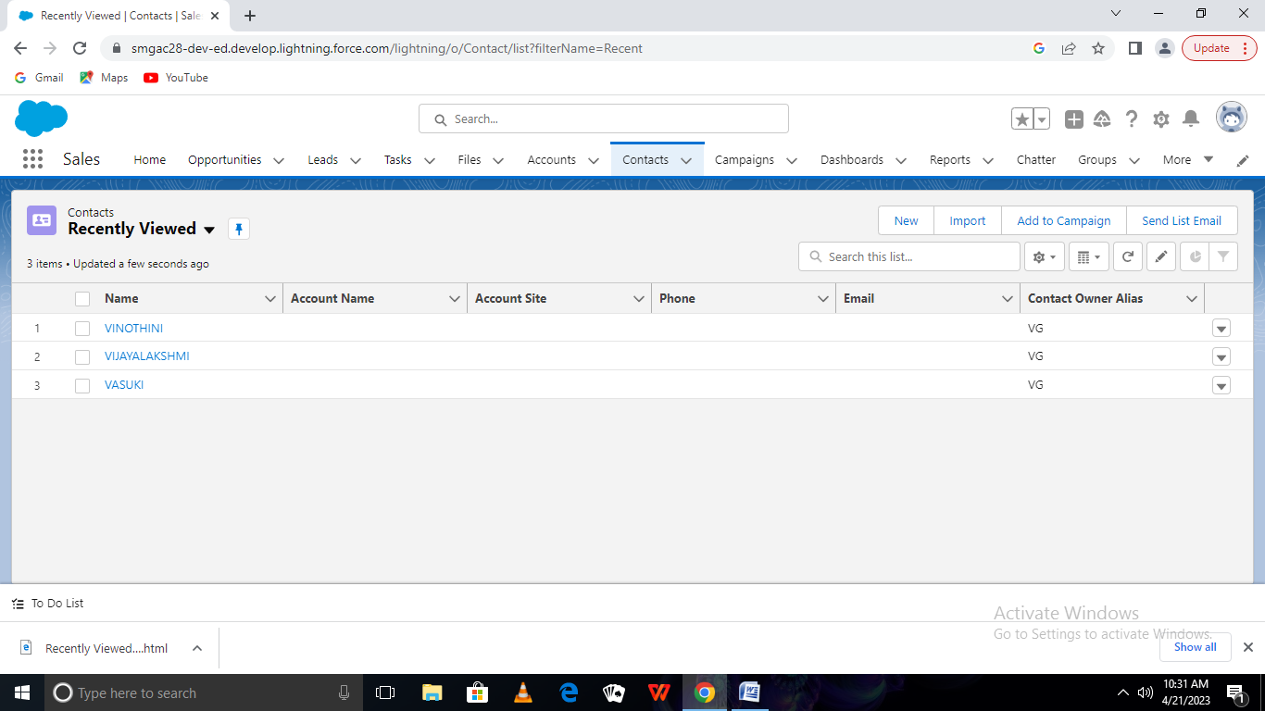

**DESCRIPTION**

In most CRM systems, the term contact designates an individual who has purchased your product or service or a company representative responsible for purchasing. The difference between a contact and a lead is that leads are POTENTIAL clients, whereas contacts are usually existing New

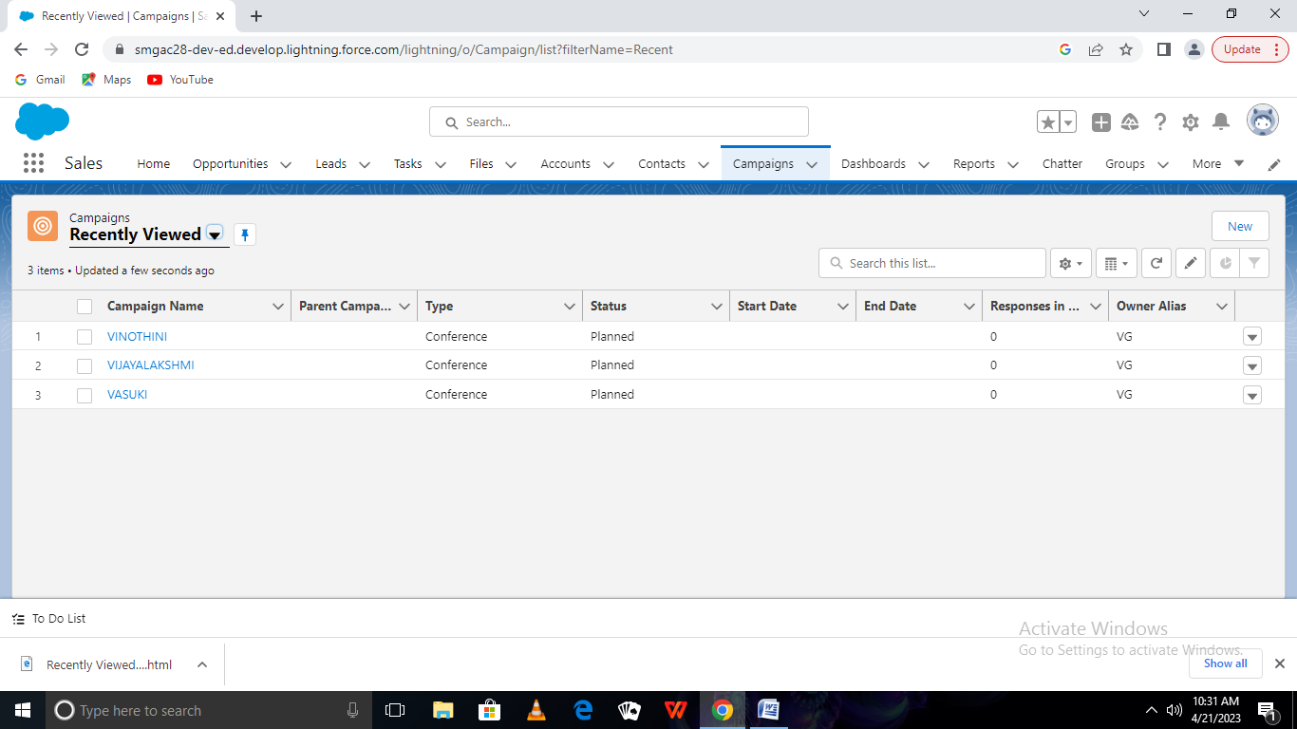

**DESCRIPTION**

This definition explains the meaning of customer relationship management (CRM) ... geographic marketing campaigns based on customers' physical locations,

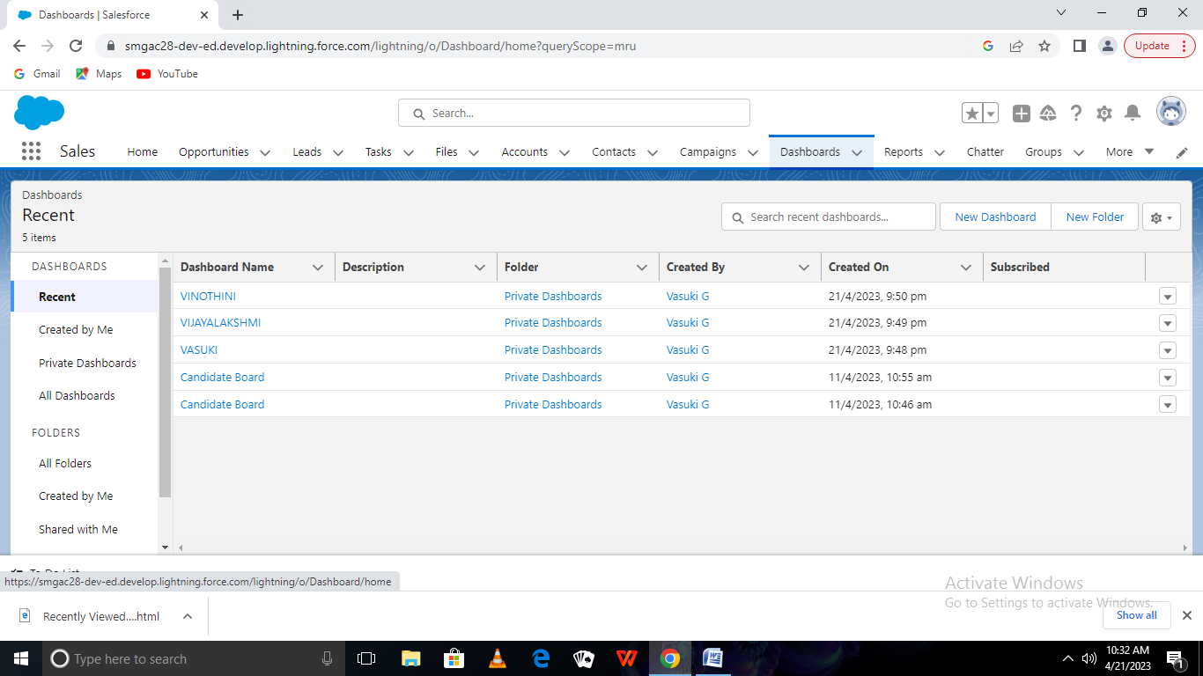

A CRM dashboard provides a broad overview of sales activity and KPIs. A CRM dashboard typically includes new leads and deals, sales pipelines, KPIs, and recent and upcoming activities

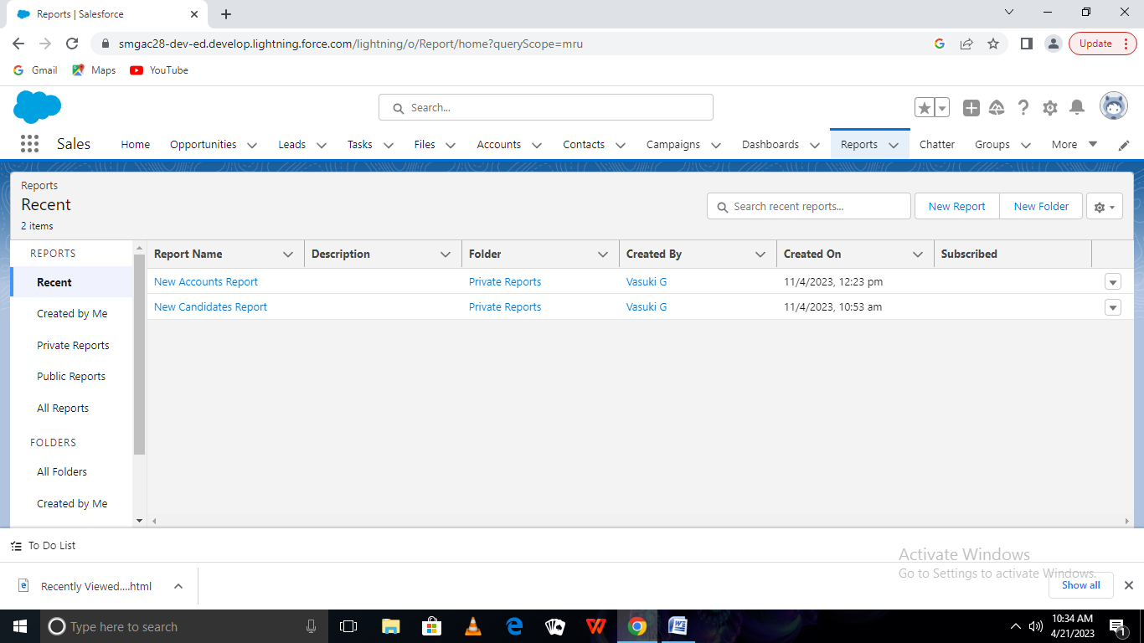

DESCRIPTION

A CRM report is a CRM tool that presents you with sales, marketing and customer support information. These Reports help you to make your analysis in a focused and efficient manner in order to make sound business decisions.

**Trailhead profile Public URL**

Team Lead –<https://trailblazer.me/id/vinothini1401>

Team Member 1-<https://trailblazer.me/id/vasuki06042003>

Team Member 2-<https://trailblazer.me/id/vijayalakshmi0502>

ADVANTAGES & DISADVANTAGE

It facilitates things by giving you and the customer, ease of communication, organized data, and improved customer service. All of this will streamline the process of making sure needs are met and actions get resolved in a timely manner

A lack of commitment or resistance to cultural change from people within the company can cause major difficulties with CRM implementation. Customer relationships may break down and result in loss of revenue, unless everyone in the business is committed to viewing their operations from the customers' perspective

APPLICATIONS

For achieving better results in CRM implementation, there needs to be careful planning, resource allocation, and management system put in place. Companies must include critical people from Marketing, Customer service, Sales & support teams in the core implementation team while planning the CRM implementation.

CONCLUSION

CRM initiatives and implementation activities within the organization is at its infancy stage. One of the main reasons could be the fact that the bank been in the industry for a period of six years and therefore much effort has not been directed in building relationships. The only document the author was able to find that linked a small degree of CRM activity was in the organizations marketing and sales strategy and therefore one could conclude that CRM initiatives at present is solely limited to this division in the organization

FUTURE SCOPE

[ FUTURE SCOPE of CRM] is about which companies will be able to pivot to meet the changing needs and trends — driven by customer expectations. Customers expect organizations to know a lot about them and expect to have conversation